Adaline (Porter) Angel
June 3, 1801 – March 22, 1877

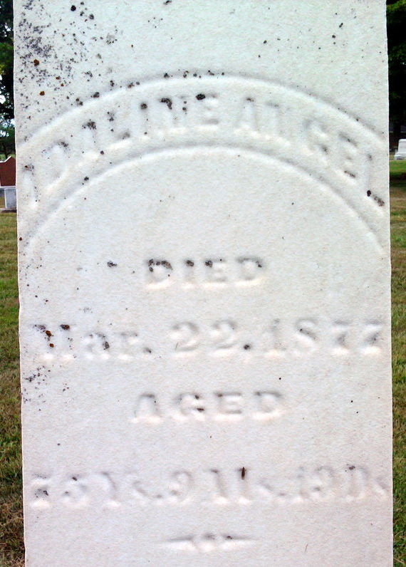
Photo by Thomas Liby
Adaline Porter from Fry Family Tree
Spouse David Angel
Father James Porter
Children Henry C
Birth 3 Jun 1801 Pennsylvania, USA
Death 22 Mar 1877 Bluffton, Wells, Indiana, USA
Residence 1860 Bluffton, Wells, Indiana, USA

