Leslie Astin Andrews
December 28, 1897 – October 19, 1944

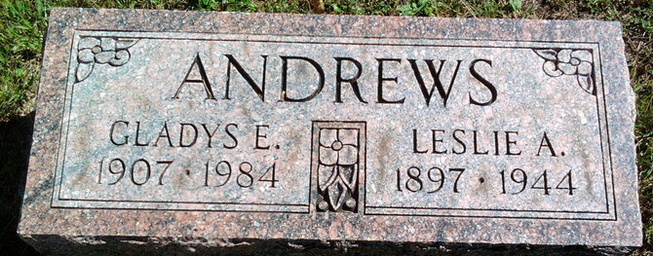
Photo by Thomas Liby
Leslie A Andrews
in the Indiana, U.S., Death Certificates, 1899-2017
Name: Leslie A Andrews
Gender: Male
Race: White
Age: 46
Marital status: Married
Birth Date: 28 Dec 1897
Birth Place: Adams County
Death Date: 19 Oct 1944
Death Place: Bluffton, Wells, Indiana, USA
Death Registration Date: 1944
Father: William E Andrews
Mother: Carolyn Brown
Spouse: Gladys Porter; age 39
Informant: Mrs. Leslie Andrews; Bluffton, Indiana
Burial: October 22, 1944; Fairview Cemetery; Bluffton, Indiana

