Gladys E. (Porter) Andrews
January 5, 1907 – July 4, 1984

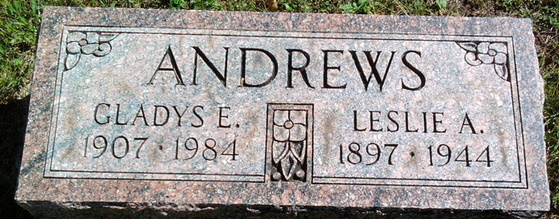
Photo by Thomas Liby
Gladys E. Andrews
in the Indiana, U.S., Death Certificates, 1899-2017
Name: Gladys E. Andrews
[Gladys E. Porter]
Gender: Female
Race: White
Age: 77
Marital status: Widowed
Birth Date: 5 Jan 1907
Birth Place: Indiana
Death Date: 4 Jul 1984
Death Place: Fort Wayne, Allen, Indiana, USA
Death Registration Date: 1984
Father: Samuel Porter
Mother: Alice Cary
Informant: Mrs. Viola Staples; daughter; Fort Wayne, Indiana
Burial: July 7, 1984; Fairview Cemetery; Bluffton, Indiana

