Robert Max Anderson
September 20, 1931 – November 29, 1958

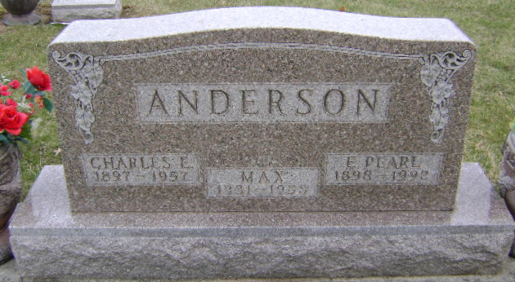
Photo by Bruce Sonner
Robert Max Anderson
in the Indiana, U.S., Death Certificates, 1899-2017
Name: Robert Max Anderson
Gender: Male
Race: White
Age: 27
Marital status: Never Married (Single)
Birth Date: 20 Sep 1931
Birth Place: Indiana
Death Date: 29 Nov 1958; auto accident
Death Place: Fort Wayne, Allen, Indiana, USA
Death Registration Date: 1958
Father: Charles E Anderson
Mother: Estelle Pearl Quirk
Informant: Marcene Miller; Bluffton, Indiana
Burial: December 2, 1958; Fairview Cemetery; Bluffton, Indiana

