Milton Richard “Dick” Anderson
August 12, 1885 – February 13, 1970

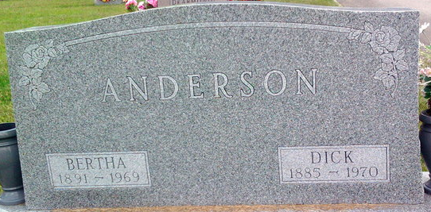
Photo by Thomas Liby
Milton Richard Anderson
in the Indiana, U.S., Death Certificates, 1899-2017
Name: Milton Richard Anderson
Gender: Male
Race: White
Age: 86
Marital status: Widowed
Birth Date: 12 Aug 1883(sic)
Birth Place: Indiana
Death Date: 13 Feb 1970
Death Place: Bluffton, Wells, Indiana, USA
Death Registration Date: 1970
Father: John Anderson
Mother: Amanda Butcher
Informant: Mrs. Richard Myers; daughter; Bluffton, Indiana
Burial: February 15, 1970; Fairview Cemetery; Bluffton, Indiana

