Michael Anderson
July 18, 1958 – July 3, 2022

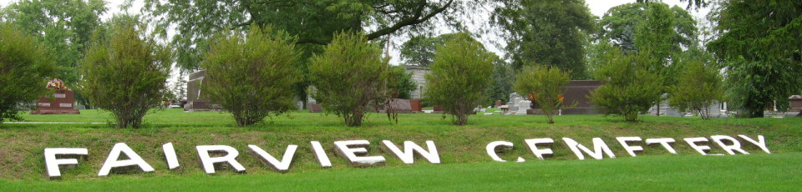
Photo by Tombstoner & Family
Michael “Mike” Anderson, 63 of Bluffton, passed away on Sunday afternoon, July 3, 2022, at his residence. Mike was born on July 18, 1958, in Anderson, Indiana to Grada & Corene (Dalton) Anderson and graduated from Marion High School.
He was currently working at 20 / 20 Custom Molding Plastics in Bluffton and formerly worked at Peyton’s Northern in Bluffton for many years.
Survivors include his two sons: Austin (Kimberly) Anderson of Illinois and Jackson Anderson of Indiana and a granddaughter, Cecilia Anderson.
He is also survived by his siblings; Connie Phillippe of Indiana, Judy Scherer of Kentucky, Marilyn Lewis of New Mexico, Carolyn Wilhoitte of Ecuador and Edward Anderson of Indiana.
Mike is preceded in death by a son, Adam Wayne Mendenhall, his parents, and siblings, Elmer Anderson, William Anderson, Bob Anderson and Martha Quaid.
Funeral services will be held at 2 P.M. on Saturday, July 9, 2022, at the Thoma/Rich, Lemler Funeral Home in Bluffton. Burial will follow at Fairview Cemetery in Bluffton. Visitation will be held from 11 A.M. to 2 P.M. on Saturday, July 9, 2022, at the funeral home, prior to the service.
Memorials may be made in Mike’s memory to Riley Children’s Hospital.

Thoma/Rich Funeral Home, Wells County, Indiana
July 4, 2022

