Kimsey “Spike” Anderson
October 30, 1924 – November 3, 2010

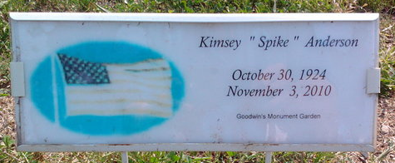
Photo by Thomas Liby
Kimsey "Spike" Anderson, 86, of Bluffton, died at 7:45 a.m. Wednesday, Nov. 3, 2010, at his residence. Mr. Anderson was born in New Haven on Oct. 30, 1924, to Milton R. and Bertha M. (Allen) Anderson. He married Gussie L. Exum in Plant City, Fla., on April 8, 1953; she survives.
A 1943 graduate of Lancaster High School, Mr. Anderson served in the U.S. Navy during World War II. He was the owner of Spikes Welding Shop in Bluffton for years, and also worked as a part time driver for Reimschisel Ford in Bluffton. He was a member of American Legion Post 111 and the First Church of Christ in Bluffton.
He was a lifelong bowler in Bluffton's Men's League. He was inducted into the Bluffton Bowling Association Hall of Fame in 1992.
Surviving relatives include one son, Rex (Mary) Anderson of Spring, Texas; one daughter, Karen (Mark) McKibben of Fort Wayne; three sisters, Edith Myers and Barb McMurtry, both of Bluffton, and Loretta Craig of Florida; two granddaughters, Erica (Hayden) Hayes and Eileen Anderson and two grandsons, Dustin and Chance McKibben.
Mr. Anderson was preceded in death by one sister, Monice Hilsmier; and three brothers, Ivan, Orval and Bernard Anderson.
Calling hours will be from 2 to 8 p.m. Friday, Nov. 5, at the Goodwin Memorial Chapel in Bluffton. Funeral services will be at 10.30 a.m. Saturday, Nov. 6, at the funeral home with Larry Sprinkle and Jim Miller officiating. Burial is at Fairview Cemetery in Bluffton, where the U.S. Navy Honor Guard and American Legion Post 111 will conduct military graveside rites.
Preferred memorials are to the First Church of Christ and Family Hospice and Palliative Care.

Goodwin Funeral Homes, Wells County, Indiana
November 4, 2010

