Jerry Lee “Andy” Anderson, II
July 16, 1969 – December 1, 1991

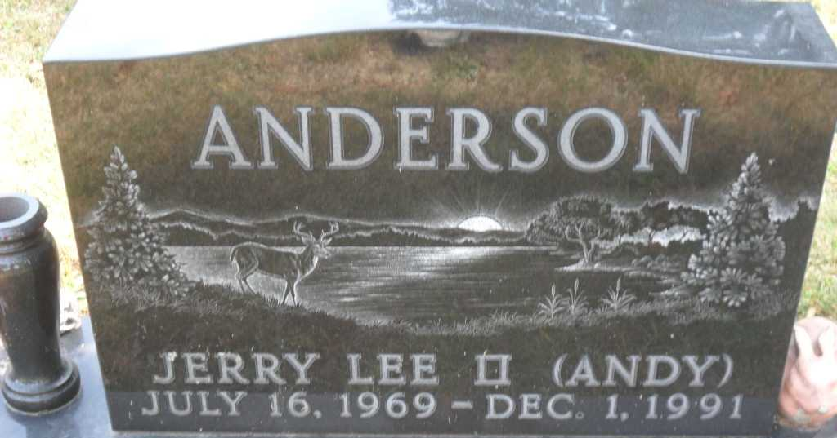
Photo by PLGS
Jerry Lee Anderson
in the Indiana, U.S., Death Certificates, 1899-2017
Name: Jerry Lee Anderson
Gender: Male
Race: White
Age: 22
Marital status: Married
Birth Date: 16 Jul 1969
Birth Place: Decatur, Indiana
Death Date: 1 Dec 1991
Death Place: Liberty Center, Wells, Indiana, USA
Death Registration Date: 1991
Father: Jerry Lee Anderson
Mother: Camelita Lavine
Spouse: Melissa Nunley
Informant: Melissa Anderson; wife; Bluffton, Indiana
Burial: December 4, 1991; Fairview Cemetery; Bluffton, Indiana

