Estelle Pearl (Quirk) Anderson
February 9, 1898 – October 2, 1992

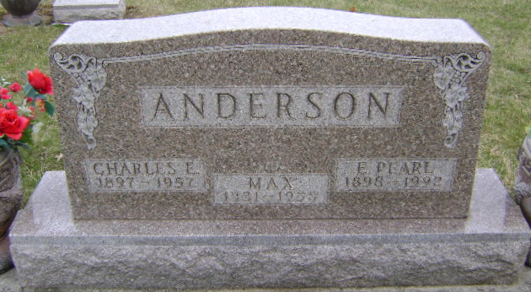
Photo by Bruce Sonner
Pearl Anderson
in the Indiana, U.S., Death Certificates, 1899-2017
Name: Pearl Anderson
[Pearl Quirk]
Gender: Female
Race: White
Age: 94
Marital status: Widowed
Birth Date: 9 Feb 1898
Birth Place: Shideler, Indiana
Death Date: 2 Oct 1992
Death Place: Bluffton, Wells, Indiana, USA
Death Registration Date: 1992
Father: Patrick Quirk
Mother: Rachael Peckenpaugh
Informant: Marcene Miller; daughter; Bluffton, Indiana
Burial: October 5, 1992; Fairview Cemetery; Bluffton, Indiana

