Col. E. W. Anderson
1827 – December 6, 1903

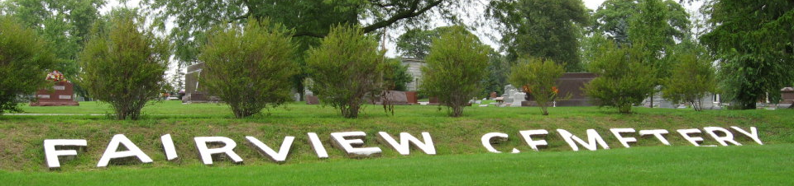
Photo by Tombstoner & Family
Col. Anderson Dead
Was found dead in his room at Bluffton Sunday Morning
Had Eventful Career
Had traveled over a Greater Portion of the World
Colonel E.W. Anderson, who for several years was employed on the Warren News and the Warren Tribune was found dead in his room at Bluffton Sunday morning. His death was due to uremic poison and heart trouble. Saturday evening he appeared to be in good health and spent several hours in conversation with a friend. About eleven o'clock he retired. In about an hour he was heard moving about his room. He stumbled and fell to the floor. He was helped to bed by Elmer Sark who roomed in the same building. Sark found the old man to be very sick and remained with him until after three o'clock when he appeared to be resting easier. When Sark entered Anderson's room about seven o'clock on Sunday morning the aged journalist was sleeping the sleep from which there is no earthly awakening. His death had apparently been a painless one, as he was found lying on his back with one arm resting on his breast.
During the three years Col. Anderson lived in Warren he made many friends, who will be sorry to hear of his lonely death. He was a man of dignified deportment, and impressed those about him as being possessed of great ability. He was a great reader, had a retentive memory, had traveled over a greater part of the globe and was a close observer of all that he saw. As a staff correspondent of the New York Herald he became acquainted with most of the notable men of his time and for years lived on familiar terms with the men who were making history. His conversational powers were of a high order and there were few subjects about which he was not informed. He took a great delight in having children with him and was seldom without a number of them about him.
Colonel Anderson was born in Maryland in 1827 and belonged to a wealthy family. His father was an extensive land owner who gave his son an excellent education. He received his early training at a private school and afterwards graduated from William and Mary's College. While still a young man he became connected with the New York Herald and rose to the position of staff correspondent. He traveled for the Herald over the continent of Europe and later embarked in the newspaper business himself. He met with reverses in business and his fortune dwindled away. During his last years he was compelled to earn his living by setting type. He came to Warren about four years ago and secured employment in the Republican office. When that paper was discontinued he worked for several months in the Tribune office. About a year ago he went to Bluffton and was given work in the News office. His health was fairly good up to the time of his death and he was able to avoid being a charge upon charity a condition which he dreaded more than anything else.
The funeral was held at Bluffton Tuesday afternoon and the remains were buried in Fairview Cemetery.

The Warren Tribune, Huntington County, Indiana
Friday, December 11, 1903

**
Indiana, U.S., Death Certificates, 1899-2017
Name: E W Anderson
Gender: Male
Race: White
Age: 75
Birth Date: abt 1828
Death Date: 6 Dec 1903
Death Place: Bluffton, Wells, Indiana, USA
Death Registration Date: 1903
Parents: Unknown
Informant: Fred M. Rinehart; Bluffton, Indiana
Burial: December 8, 1903; Fairview Cemetery

