Charles E. Anderson
April 28, 1897 – January 19, 1957

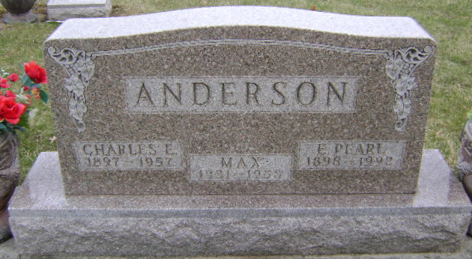
Photo by Bruce Sonner
Charles Anderson
in the Indiana, U.S., Death Certificates, 1899-2017
Name: Charles Anderson
Gender: Male
Race: White
Age: 59
Marital status: Married
Veteran: World War I
Birth Date: 28 Apr 1897
Birth Place: Indiana
Death Date: 19 Jan 1957
Death Place: Bluffton, Wells, Indiana, USA
Death Registration Date: 1957
Father: John B. Anderson
Mother: Mary Pusey
Informant: None listed
Burial: January 21, 1957; Fairview Cemetery; Wells County

