Bertha Mae (Allen) Anderson
February 20, 1891 – December 28, 1969

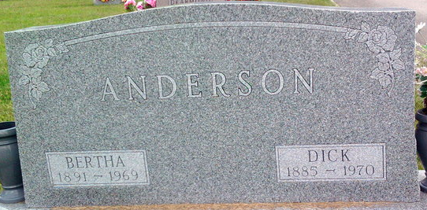
Photo by Thomas Liby
Bertha Mae Anderson
in the Indiana, U.S., Death Certificates, 1899-2017
Name: Bertha Mae Anderson
[Bertha Mae Allen]
Gender: Female
Race: White
Age: 77
Marital status: Married
Birth Date: 20 Feb 1892
Birth Place: Indiana
Death Date: 28 Dec 1969
Death Place: Bluffton, Wells, Indiana, USA
Death Registration Date: 1969
Father: John Allen
Mother: Victoria Baker
Spouse: M R Anderson
Informant: M. R. Anderson; husband; Bluffton, Indiana
Burial: December 30, 1969; Fairview Cemetery; Bluffton, Indiana

