Mary E. (Montgomery) Altenburg
October 1874 – April 3, 1955

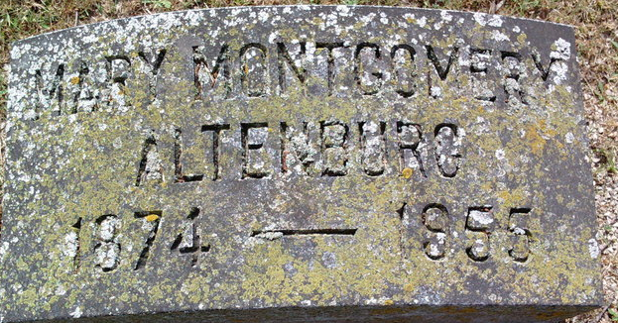
Photo by Thomas Liby
Mary M Altenburg
in the U.S., Newspapers.com™ Obituary Index, 1800s-current
Name: Mary M Altenburg
Gender: Female
Residence Place: 59 State St - J Uneral
Death Date: 3 Apr 1955
Death Place: Portuld
Obituary Date: 26 Apr 1955
Obituary Place: Portland, Maine, USA
Newspaper Title: Portland Evening Express
Spouse: Harry Q AL Unburg
**
Mary E. MONTGOMERY from tree Altenburg Family Tree
Birth Oct 1874 Bluffton, Wells, Indiana, USA
Marriage 8 Jun 1898 Bluffton, Wells, Indiana, USA
Residence 1950 Portland, Cumberland, Maine, USA
Death 1955 Cumberland, Maine, USA
Father Elijah H. MONTGOMERY (1835-1906)
Mother Harriet WILEY (1838-1922)
Spouse Harry Quinn ALTENBURG (1866-1950)

