Harry Quinn Altenburg
October 20, 1866 - 1950

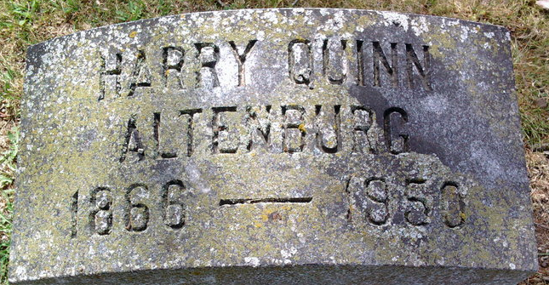
Photo by Thomas Liby
Harry Quinn ALTENBURG from Altenburg Family Tree
Spouse Mary E. MONTGOMERY
Father Pvt. Henry Esidore Altenburg
Mother Sarah C. Bodine
Children Harry Montgomery
Birth Oct 1866 Auburn, De Kalb, Indiana, USA
Death 1950
Residence 1880 Auburn, De Kalb, Indiana, USA
**
U.S., Newspapers.com™ Obituary Index, 1800s-current
Name: Harry Q Altenburg
Gender: Male
Death Age: 83
Birth Date: 20 Oct 1866
Birth Place: Auburn Ind
Residence Place: Portland
Death Date: Abt 1950
Death Place: 59 State Street
Obituary Date: 7 Oct 1950
Obituary Place: Portland, Maine, USA
Newspaper Title: Portland Evening Express
Parents: Henry C AL-Tenburg; Sara Cordelia AL-Tenburg
Siblings: Eugene C Altenburg, John D Altenburg

