Harry Montgomery Altenburg
1900 – September 22, 1906

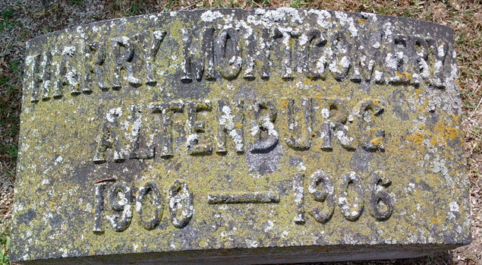
Photo by Thomas Liby
BOY KILLED BY STREET CAR
Steps on Track Directly in Front of the Approaching Car
MOTHER PROSTRATED AND FATHER FAINTS
DES MOINES, Sept. 22. — (Special) — Harry M. Altenburg, a 6-year-old boy, was almost instantly killed today at Seventeenth and Woodland by a street car running over him. He had been sent to the grocery on an errand by his mother and tried to cross the street in front of a car. Seeing his danger he stopped exactly in the middle of the track. Although the car was slowing up to stop at the farther side of the street the motorman was unable to get it stopped in time to save the boy. The car cut his legs off and crushed in the little fellow’s chest.
The family live at 679 West Eighteenth Street and the father, Henry Altenburg, a traveling man for the Dental Marshall Company, was today in Iowa City. When informed of the accident by telegraph he fainted. The mother has been in the care of physicians ever since the accident. The parents are young people and the boy was their only child.

The Omaha Sunday Bee, Omaha, Nebraska
Sunday, September 23, 1906

**
Harry Montgomery ALTENBURG from Altenburg Family Tree
Father Harry Quinn ALTENBURG
Mother Mary E. MONTGOMERY
Birth 1900 USA
Death 22 Sep 1906 Des Moines, Iowa, USA

