Mabel Geneva (Staley) Alsup
April 10, 1901 – August 30, 1975

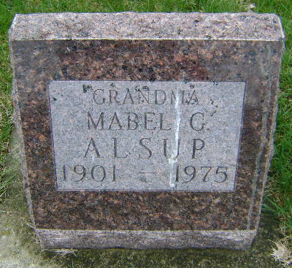
Photo by Bruce Sonner
Mabel Geneva Alsup
Death • Illinois, Cook County Deaths, 1871-1998
Name Mabel Geneva Alsup
Sex Female
Age 73
Address 407 S Wiley St
Burial Date 03 Sep 1975
Burial Place Bluffton, , Indiana
Death Date 30 Aug 1975
Death Place Chicago, Cook, Illinois, United States
Birth Date 10 Apr 1902 [sic]
Birthplace , , Iowa
Marital Status Widowed
Occupation Homemaker
Race White
Father's Name John Marion Staley
Mother's Name Samantha Jane Williams
Entry Number 620984
Cemetery Fairview Cemetery
Funeral Home Johnson Mortuary

