Lars Nordenberg Alstoft
July 4, 2011 – July 4, 2011

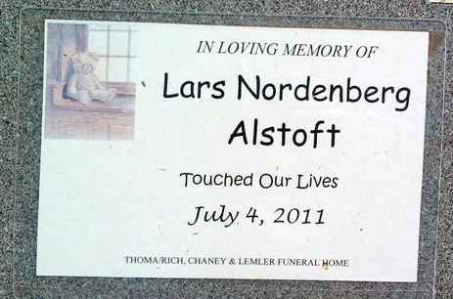
Photo by Thomas Liby
Lars Nordenberg Alstoft was born stillborn at 11:18 p.m. Monday, July 4, 2011, at Lutheran Hospital in Fort Wayne.
Surviving relatives include his parents, Bo and Keely (Meade) Alstoft of Bluffton; three brothers, Jordan Alstoft of Bluffton, Casper Alstoft of Hartford City and Benjamin Alstoft of Liberty Center; and grandparents, Rex and Teresa Meade of Ontario, Canada, and Flemming and Kate Alstoft of Glostrup, Denmark.
Lars was also preceded in death by an infant sister, Audrey Meade Alstoft, on Jan. 4, 2008.
Graveside services will be at 4 p.m. Saturday, July 9, at Fairview Cemetery in Bluffton with certified funeral celebrant Jeff Lemler officiating.
Preferred memorials are to the Wells County Friends of the Shelter.

Thoma/Rich Funeral Home, Wells County, Indiana
July 5, 2011

