Audrey Meade Alstoft
January 4, 2008 – January 4, 2008

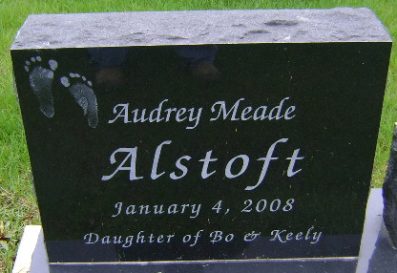
Photo by Bruce Sonner
Audrey Meade Alstoft from Alstoft Family Tree
Birth 4 Jan 2008 Fort Wayne, Allen, Indiana, USA
Death 4 Jan 2008 Fort Wayne, Allen, Indiana, USA
**
Infant Audrey Meade Alstoft
The infant of Bluffton residents, Audrey Meade Alstoft was stillborn at 7:59 a.m. Friday, Jan. 4, 2007 at Lutheran Hospital in Fort Wayne.
Surviving relatives include parents, Bo & Keely (Meade) Alstoft; three brothers, Jordan Alstoft of Bluffton, Casper Alstoft of San Antonio, Texas and Benjamin Alstoft of Liberty Center; grandparents, Rex and Teresa Meade of Ontario, Canada and Flemming and Kate Alstoft of Glostrup, Denmark.
Private family graveside services will be held at Fairview Cemetery with Mayor Ted Ellis officiating.
Preferred memorials are to the family Centered Services.

Bluffton News-Banner, Wells County, Indiana
Saturday, January 5, 2008, p. 3, c. 1

