Evaline Anne (Justus) Alspach
December 7, 1887 – March 13, 1944

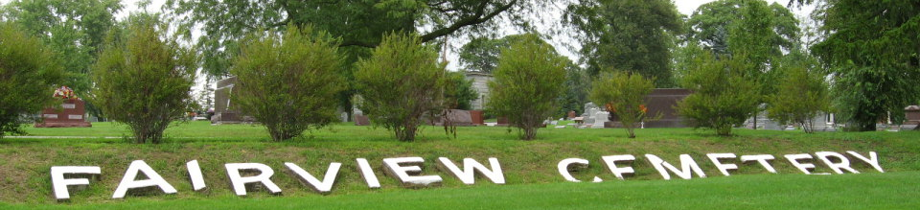
Photo by Tombstoner & Family
Evaline Anne Alspach
in the Indiana, U.S., Death Certificates, 1899-2017
Name: Evaline Anne Alspach
[Evaline Anne Justus]
Gender: Female
Race: White
Age: 56
Marital status: Married
Birth Date: 7 Dec 1887
Birth Place: Indiana
Death Date: 13 Mar 1944
Death Place: Rural, Wells, Indiana, USA
Death Registration Date: 1944
Father: James Justus
Mother: Nora Pace
Spouse: Max Alspach; age 40
Informant: Max Alspach; Warren, Indiana
Burial: March 15, 1944; Fairview Cemetery; Bluffton, Indiana

