Philemon A. Allen
January 29, 1853 – February 5, 1942

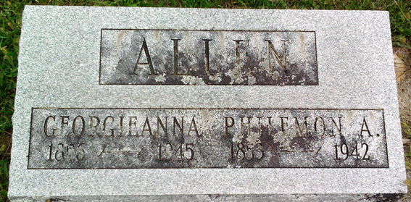
Photo by Thomas Liby
Philemon A Allen
in the Indiana, U.S., Death Certificates, 1899-2017
Name: Philemon A Allen
Gender: Male
Race: White
Age: 89
Marital status: Married
Birth Date: 29 Jan 1853
Birth Place: Whitley Co Indiana
Death Date: 5 Feb 1942
Death Place: Bluffton, Wayne, Indiana, USA
Death Registration Date: 1942
Father: Nathaniel Allen
Mother: Elizabeth Force
Spouse: Georgianna Swaim
Informant: Mrs. P. A. Allen
Burial: February 7, 1942; Fairview Cemetery; Bluffton, Indiana

