Murray B. Allen
August 10, 1911 – October 20, 1955

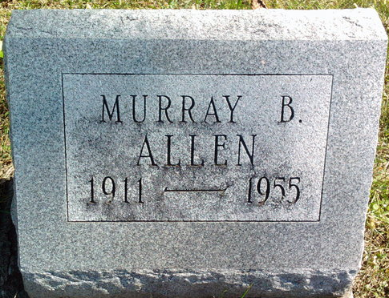
Photo by Thomas Liby
Murray B Allen
in the Indiana, U.S., Death Certificates, 1899-2017
Name: Murray B Allen
Gender: Male
Race: White
Age: 44
Marital status: Never Married (Single)
Birth Date: 10 Aug 1911
Birth Place: Illinois
Death Date: 20 Oct 1955
Death Place: Bluffton, Wells, Indiana, USA
Death Registration Date: 1955
Father: C Forrest Allen
Mother: Grace Murray
Informant: Charles Forrest Allen, Jr.; Fort Wayne, Indiana
Burial: October 24, 1955; Fairview Cemetery; Bluffton, Indiana

