Lucile Allen
October 2, 1888 – February 6, 1891

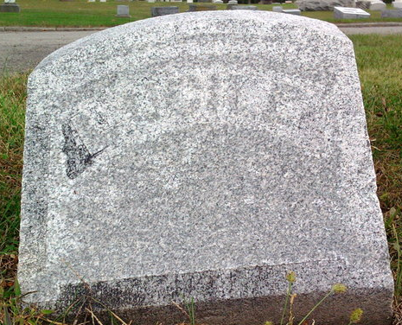
Photo by Thomas Liby
Lucille Allen from Zuber/Linder Family Tree
Father Philemon A. Allen
Mother Georgiana Swaim
Birth 2 Oct 1888
Death 6 Feb 1891

