Jeffery Allen
May 5, 1955 – May 5, 1955

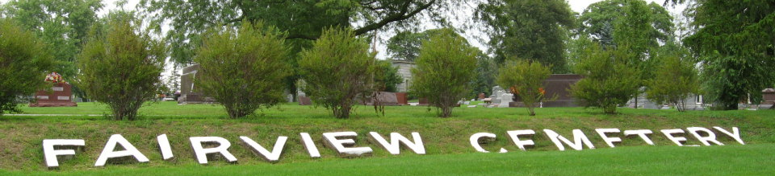
Photo by Tombstoner & Family
Jeffery Allen
in the Indiana, U.S., Death Certificates, 1899-2017
Name: Jeffery Allen
Gender: Male
Race: White
Age: 21 minutes
Marital status: Married
Birth Date: 5 May 1955
Birth Place: Fort Wayne, Indiana
Death Date: 5 May 1955; premature
Death Place: Fort Wayne, Allen, Indiana, USA
Death Registration Date: 1955
Father: Eugene Allen
Mother: Patricia Powell
Informant: Eugene Allen
Burial: May 7, 1955; Fairview Cemetery; Bluffton, Indiana

