Grace Katherine (Murray) Allen
June 27, 1886 – August 13, 1955

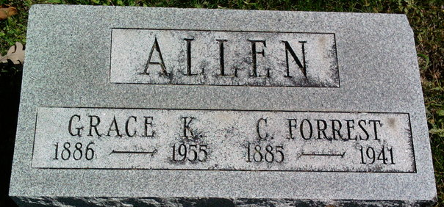
Photo by Thomas Liby
Grace Katherine Allen
in the Indiana, U.S., Death Certificates, 1899-2017
Name: Grace Katherine Allen
[Grace Katherine Murray]
Gender: Female
Race: White
Age: 69
Marital status: Widowed
Birth Date: 27 Jun 1886
Birth Place: Illinois
Death Date: 13 Aug 1955
Death Place: Bluffton, Wells, Indiana, USA
Death Registration Date: 1955
Father: P J Murray
Mother: Evelyn Austin
Informant: Murray Allen; Bluffton, Indiana
Burial: August 16, 1955; Fairview Cemetery; Bluffton, Indiana

