Georgieanna (Swaim) Allen
June 12, 1856 – August 29, 1945

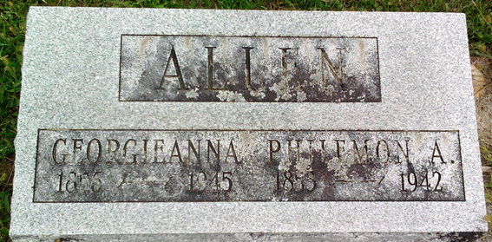
Photo by Thomas Liby
Georgianna Allen
in the Indiana, U.S., Death Certificates, 1899-2017
Name: Georgianna Allen
[Georgianna Swaim]
Gender: Female
Race: White
Age: 89
Marital status: Widowed
Birth Date: 12 Jun 1856
Birth Place: Troy Ohio
Death Date: 29 Aug 1945
Death Place: Bluffton, Wells, Indiana, USA
Death Registration Date: 1945
Father: Tanton Swaim
Mother: Rebecca Pawell
Spouse: Philemon A Allen
Informant: Mrs. Grace Allen; Bluffton, Indiana
Burial: August 31, 1945; Fairview Cemetery; Bluffton, Indiana

