Deborah Allen
November 6, 1952 – November 6, 1952

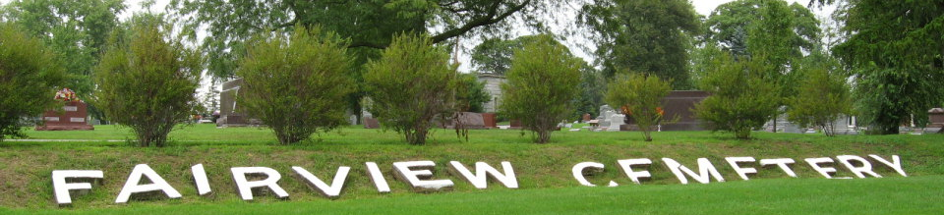
Photo by Tombstoner & Family
Deborah Allen
in the Indiana, U.S., Death Certificates, 1899-2017
Name: Deborah Allen
Gender: Female
Race: White
Age: 2 hours
Marital status: Single
Birth Date: 6 Nov 1952
Birth Place: Ft Wayne, Indiana
Death Date: 6 Nov 1952
Death Place: Fort Wayne, Allen, Indiana, USA
Death Registration Date: 1952
Father: Eugene Allen
Mother: Patricia Powell
Informant: Eugene Allen; father; Fort Wayne, Indiana
Burial: November 10, 1952; Fairview Cemetery; Bluffton, Indiana

