Charles Forrest Allen
September 28, 1885 – August 9, 1941

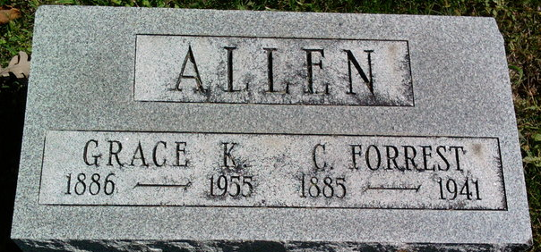
Photo by Thomas Liby

Allen C Forrest Allen Sr
in the U.S., Newspapers.com™ Obituary Index, 1800s-current
Name: Allen C Forrest Allen Sr
Gender: Male
Residence Place: 2125 Oxford
Death Date: Abt 1941
Death Place: Buffton Ind
Obituary Date: 9 Aug 1941
Obituary Place: Albuquerque, New Mexico, USA
Newspaper Title: The Albuquerque Tribune
Father: P A Allen
Child: C Forrest, Forrest J, Edgar Bowden, William H Webb
**
U.S., Newspapers.com™ Obituary Index, 1800s-current
Name: Charles Forrest Allen
Gender: Male
Death Age: 55
Birth Date: 28 Sep 1885
Birth Place: Bluffton
Marriage Date: 8 Oct 1910
Marriage Place: Chicago
Residence Place: Bluff ton, Ind.
Death Date: Abt 1941
Death Place: Prof
Burial Date: 9 Aug
Obituary Date: 10 Aug 1941
Obituary Place: Muncie, Indiana, USA
Newspaper Title: The Star Press
Father: P. A. Allen
Spouse: Grace Murray
Child: Murray Allen, Forrest Allen,
William H. Webb
**
Charles Forrest Allen from tree Allen Family Tree
Birth 28 Sep 1885 Bluffton, Clay, Georgia, USA
Marriage 28 Sep 1910 Chicago, Cook, Illinois, USA
Residence 1940 Albuquerque, Bernalillo, New Mexico, USA
Death 9 Aug 1941 Prof
Record information.
Father Philemon A Allen (1853-1942)
Mother Georgianna Swaim (1856-1945)
Spouse Grace Katherine Murray (1886-1955)

