Eliza Elenor (Stewart) Alger
February 15, 1828 – March 2, 1910

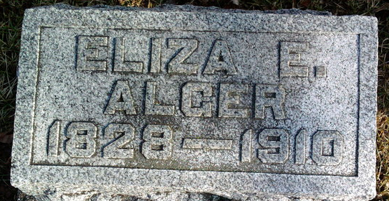
Photo by Thomas Liby
Eliza Elenor Alger
in the Indiana, U.S., Death Certificates, 1899-2017
Name: Eliza Elenor Alger
[Eliza Elenor Stewart]
Gender: Female
Race: White
Age: 82
Marital status: Widowed
Birth Date: 15 Feb 1828
Birth Place: Clinton
Death Date: 2 Mar 1910
Death Place: Bluffton, Wells, Indiana, USA
Death Registration Date: 1910
Father: Edwin Stewart
Spouse: S. J. Alger
Informant: Family; Bluffton, Indiana
Burial: March 4, 1910; Fairview Cemetery

**
Eliza Eleanor Stewart from tree Sickler-Snyder Family Tree
Birth 15 Feb 1828 New York, USA
Marriage 29 Jan 1851
Residence 1900 Wells, Indiana, USA
Death 2 Mar 1910 Bluffton, Wells, Indiana, USA
Father Edwin A. Stewart (1788-1871)
Mother Elizabeth Johnson (1794-1870)
Spouse Sylvester Jackson Alger (1830-1881)

