Rhoda Jane (Loehr) Alexander
August 8, 1900 – July 30, 1993

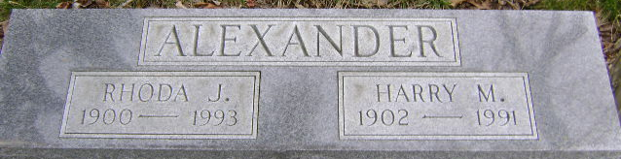
Photo by Bruce Sonner

Rhoda Jane Alexander
in the Indiana, U.S., Death Certificates, 1899-2017
Name: Rhoda Jane Alexander
[Rhoda Jane Loehr]
Gender: Female
Race: White
Age: 92
Marital status: Widowed
Birth Date: 8 Aug 1900
Birth Place: Freeport, Indiana
Death Date: 30 Jul 1993
Death Place: Fort Wayne, Allen, Indiana, USA
Death Registration Date: 1993
Father: Jacob C Loehr
Mother: Amanda Jane Catt
Informant: Cindy Kimsey; friend; Bluffton, Indiana
Burial: August 1, 1993; Fairview Cemetery; Bluffton, Indiana

