Marcellus Alexander
August 11, 1844 – November 22, 1923

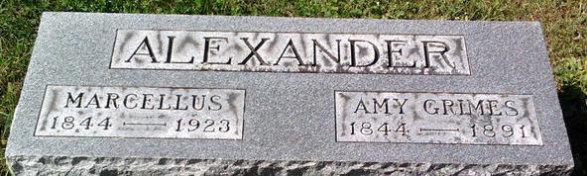
Photo by Thomas Liby

Marcellus Alexander
in the Indiana, U.S., Death Certificates, 1899-2017
Name: Marcellus Alexander
Gender: Male
Race: White
Age: 79
Marital status: Widowed
Birth Date: 11 Aug 1844
Birth Place: Jackson Indiana
Death Date: 22 Nov 1923
Death Place: Bluffton, Wells, Indiana, USA
Death Registration Date: 1923
Father: Edward Alexander
Mother: Elizabeth Stewart
Spouse: Kittie Johnston Sprowl
Informant: Family; Bluffton, Indiana
Burial: November 25, 1923; Fairview Cemetery

