Harry M. Alexander
January 14, 1902 – December 8, 1991

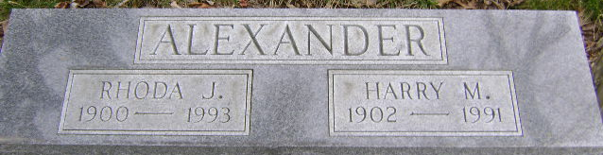
Photo by Bruce Sonner

Harry Alexander
in the Indiana, U.S., Death Certificates, 1899-2017
Name: Harry Alexander
Gender: Male
Race: White
Age: 89
Marital status: Married
Birth Date: 14 Jan 1902
Birth Place: Madison County, Indiana
Death Date: 8 Dec 1991
Death Place: Bluffton, Wells, Indiana, USA
Death Registration Date: 1991
Father: Thomas Alexander
Mother: Addie Jackson
Spouse: Rhoda Jane Loehr
Informant: Rhoda Jane Alexander; wife; Bluffton, Indiana
Burial: December 11, 1991; Fairview Cemetery; Bluffton, Indiana

