Fay M. (Hedges) Alexander
September 13, 1913 – August 23, 1941

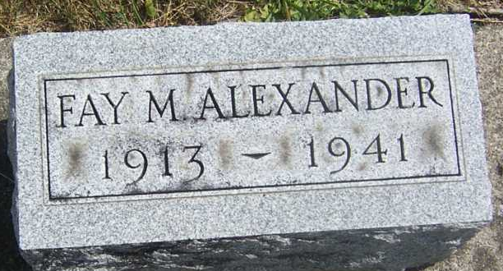
Photo by PLGS

Jay Heddie Alexander
in the Indiana, U.S., Death Certificates, 1899-2017
Name: Fay Hedges Alexander
[Fay Hedges]
Gender: Female
Race: White
Age: 27
Marital status: Married
Birth Date: 13 Sep 1913
Birth Place: Bluffton Wills Co Indiana
Death Date: 23 Aug 1941
Death Place: Rural, Wells, Indiana, USA
Death Registration Date: 1941
Father: Earl Hedges
Mother: Jessie Aker
Spouse: John Alexander
Informant: John Alexander; Bluffton, Indiana
Burial: August 26, 1941; Fairview Cemetery; Bluffton, Indiana

