Catharine (Johnston) Alexander
October 31, 1863 – June 13, 1917

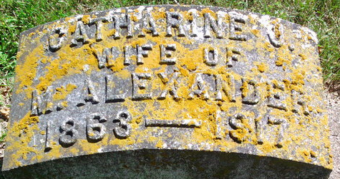
Photo by Thomas Liby

Catharine Johnston Alexander
in the Indiana, U.S., Death Certificates, 1899-2017
Name: Catharine Alexander
[Catharine ??Ston]
Gender: Female
Race: White
Age: 54
Marital status: Married
Birth Date: 31 Oct 1863
Birth Place: Indiana
Death Date: 13 Jun 1917
Death Place: Bluffton, Wells, Indiana, USA
Death Registration Date: 1917
Father: Wm ??Ston
Mother: Craig
Spouse: Marcellus Alexander
Burial: June 15, 1917; Fairview Cemetery

