Amy (Grimes) Alexander
1844 - 1891

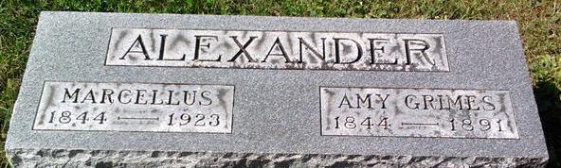
Photo by drbuck

Amy GRIMES in tree Carson Locke (Linked)
Spouse John B KING; Marcellus Alexander
Father Charles GRIMES
Mother Martha Unknown
Birth 1844 Indiana, USA
Death 1891 Wells, Indiana, USA
Residence 1860 Wells, Indiana, USA

