Luis Gabriel Aldin
March 24, 1945 – December 23, 1986

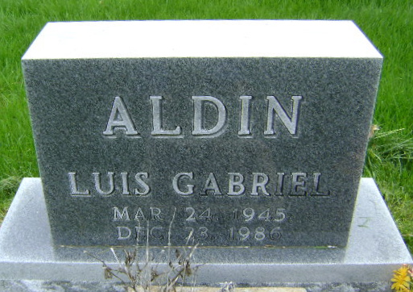
Photo by Bruce Sonner

Luis Gabriel Aldin
in the Indiana, U.S., Death Certificates, 1899-2017
Name: Luis Gabriel Aldin
Gender: Male
Race: White
Age: 41
Marital status: Married
Birth Date: 24 Mar 1945
Birth Place: Cuba City
Death Date: 23 Dec 1986
Death Place: Fort Wayne, Allen, Indiana, USA
Death Registration Date: 1986
Father: Juan Aldin
Mother: Perez Blanca
Spouse: Mary Ann
Informant: Mary Ann Aldin; wife; Fort Wayne, Indiana
Burial: December 24, 1986; Fairview Cemetery; Bluffton, Indiana

