David Gabriel Aldin
May 23, 1973 – October 20, 2006

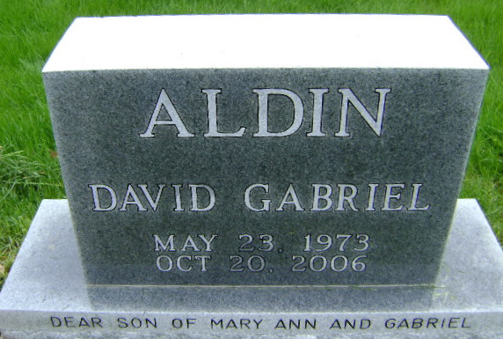
Photo by Bruce Sonner

David G. Aldin, 33, died Friday, October 20, 2006. He was born in Fort Wayne and graduated from North Side High School & Ivy Tech State College. He loved music and was an accomplished guitarist. He was a friend to all animals and enjoyed children.
Survivors include his mother, Mary Ann Aldin of Fort Wayne; brother, Ryan (Jessica) Aldin of Hilliard, OH; sister, Erica Aldin of Budd Lake, NJ. He was preceded in death by his father, L. Gabriel Aldin.
Services were entrusted to Mungovan and Sons Funeral Home of Fort Wayne, Indiana.

Journal-Gazette, Allen County, Indiana
October 21, 2006

**
David G Aldin
in the Indiana, U.S., Death Certificates, 1899-2017
Name: David G Aldin
Gender: Male
Race: White
Age: 33
Marital status: Never Married (Single)
Birth Date: 23 May 1973
Birth Place: Fort Wayne Indiana
Death Date: 20 Oct 2006; suicide by gun shot
Death Place: Bluffton, Wells, Indiana, USA
Death Registration Date: 2006
Father: L Gabriel Aldin
Mother: Mary Ann Baumgartner
Informant: Mary Ann Aldin; mother; Fort Wayne, Indiana
Cremation: Northern Indiana Crematory; Fort Wayne, Indiana

