Gregory Alan Albright
January 18, 1967 – September 3, 2000

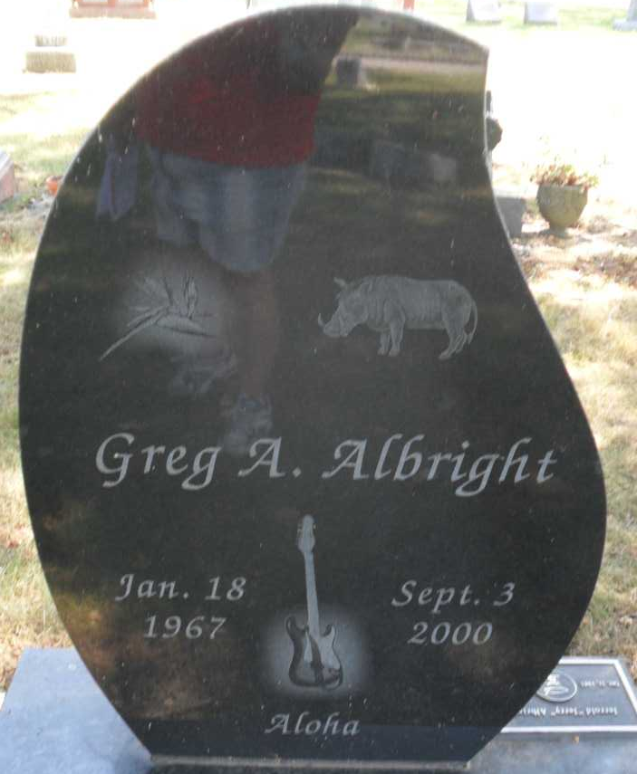
Photo by PLGS
Greg A. Albright
in the U.S., Newspapers.com™ Obituary Index, 1800s-current
Name: Greg A. Albright
Gender: Male
Death Age: 33
Birth Date: abt 1967
Birth Place: Lafayette
Residence Place: Muncie
Death Date: 3 Sep 2000
Death Place: Kirtustown, Hawaii
Burial Place: Bluffton
Obituary Date: 9 Sep 2000
Obituary Place: Muncie, Indiana, USA
Newspaper Title: The Star Press
Father: Jerry Albright
Mother: Marlene Steveson
Siblings: Kerri Boughman
**
U.S., Social Security Applications and Claims Index, 1936-2007
Name: Greg Alan Albright
[Gregory A Albright]
Gender: Male
Race: White
Birth Date: 18 Jan 1967
Birth Place: Lafayette Ti, Indiana [Lafayette, Indiana]
Death Date: 3 Sep 2000
SSN: xxx
Relationship of Signature: Not signed (blank, typed or unwitnessed mark).
Notes: 16 May 1974: Name listed as GREG ALAN ALBRIGHT; 13 Sep 2000: Name listed as GREGORY A ALBRIGHT

