Estella (Koenig) Albright
April 7, 1895 – April 12, 1916

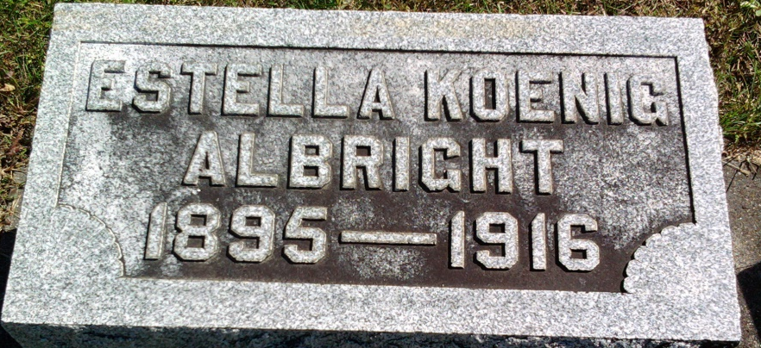
Photo by Thomas Liby

Stella Konig Albring
in the Indiana, U.S., Death Certificates, 1899-2017
Name: Stella Konig Albright
[Stella Konig ]
Maiden Name: Albright
Gender: Female
Race: White
Age: 24
Marital status: Married
Birth Date: 7 Apr 1895
Birth Place: Bluffton, Indiana
Death Date: 12 Apr 1916; following ectopic pregnancy
Death Place: Bluffton, Wells, Indiana, USA
Death Registration Date: 1916
Father: Jacob Konig
Mother: Theresine Geridin
Spouse: George Albright
Informant: Family; Bluffton, Indiana
Burial: April 14, 1916; Fairview Cemetery

