William R. Aker
June 20, 1852 – March 8, 1927

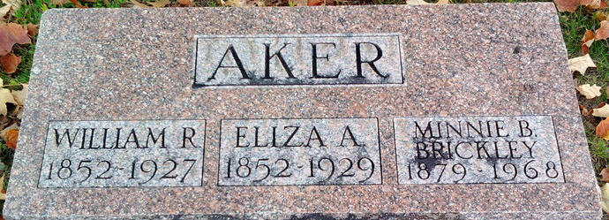
Photo by Thomas Liby

William R. Akers
in the Indiana, U.S., Death Certificates, 1899-2017
Name: William R. Akers
Gender: Male
Race: White
Age: 74
Marital status: Married
Birth Date: 20 Jun 1852
Birth Place: Wells Co Indiana
Death Date: 8 Mar 1927
Death Place: Bluffton, Wells, Indiana, USA
Death Registration Date: 1926 - 1927
Father: David Akers
Mother: Sarah Davis
Spouse: Eliza Grove
Informant: Mrs. Wm. Akers; Bluffton, Indiana
Burial: March 10, 1927; Fairview Cemetery

