Raymond W. Aker
April 27, 1908 – October 17, 1978

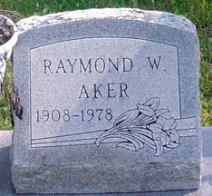
Photo by Thomas Liby

Raymond W Aker
in the Indiana, U.S., Death Certificates, 1899-2017
Name: Raymond W Aker
Gender: Male
Race: White
Age: 70
Marital status: Married
Birth Date: 27 Apr 1908
Birth Place: Indiana
Death Date: 17 Oct 1978
Death Place: Fort Wayne, Allen, Indiana, USA
Death Registration Date: 1978
Father: Charles T Aker
Mother: Lavina Falk
Spouse: Cleo Bennett
Informant: Mrs. Cleo Aker; Craigville, Indiana
Burial: October 20, 1978; Fairview Cemetery; Bluffton, Indiana

