Minnie France (Falk) Aker
October 8, 1873 – April 27, 1946

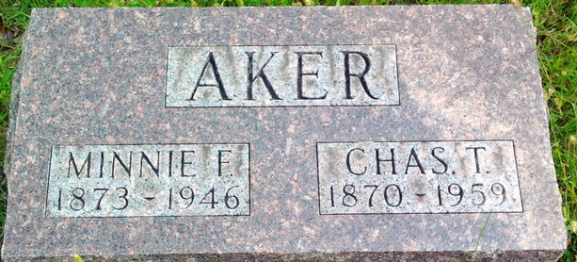
Photo by Thomas Liby

Minnie France Aker
in the Indiana, U.S., Death Certificates, 1899-2017
Name: Minnie France Aker
[Minnie France Falk]
Gender: Female
Race: White
Age: 72
Marital status: Married
Birth Date: 8 Oct 1873
Birth Place: Rockcreek Twp. Wells County
Death Date: 27 Apr 1946
Death Place: Rural, Wells, Indiana, USA
Death Registration Date: 1946
Father: John Falk
Mother: Hellen Denwitt
Spouse: Charles Aker
Informant: Charles Aker; Bluffton, Indiana
Burial: April 29, 1946; Fairview Cemetery; Bluffton, Indiana

