Jeanetta H. Aker
October 25, 1916 – January 31, 2004

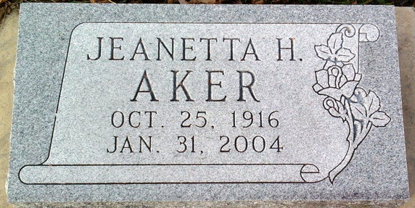
Photo by Thomas Liby
Jeanetta H. Aker, 87
A native of Bluffton, Jeanetta H. Aker, 87, of Angola, died at 2:15 p.m. Saturday, Jan. 31 at Lakeland Nursing Center in Angola.
She was born Oct. 25, 1916 to Charles and Minnie Falk Aker. She was a cook for 30 years for Bledsoe’s Hotel and also worked at Bledsoe’s Basketball Camp, Angola
Survivors include many nieces and nephews.
She was preceded in death by several brothers and sisters and her special friend, Clarence Keller.
Calling will be held starting at 11 a.m. Saturday until time of services at 1 p.m. at Johnson-Klink Funeral Home, Angola. Burial will be in the Fairview Cemetery in Bluffton.

Bluffton News Banner, Wells County, Indiana
February 3, 2004

