Eliza Ann (Grove) Aker
November 2, 1852 – November 3, 1929

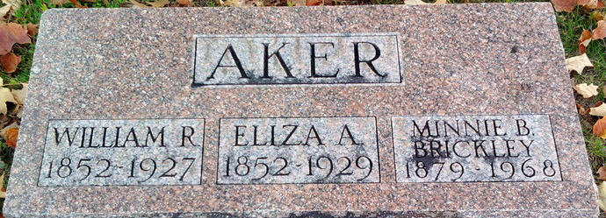
Photo by Thomas Liby

Eliza Ann Aker
in the Indiana, U.S., Death Certificates, 1899-2017
Name: Eliza Ann Aker
[Eliza Ann Grove]
Gender: Female
Race: White
Age: 79
Marital status: Widow
Birth Date: 2 Nov 1852
Birth Place: Wells Co Indiana
Death Date: 3 Nov 1929
Death Place: Bluffton, Wells, Indiana, USA
Death Registration Date: 1929
Father: James Grove
Mother: Caroline Smith
Spouse: Wm Aker; deceased
Informant: Chas. Aker; Bluffton, Indiana
Burial: November 5, 1929; Fairview Cemetery

