Charles Theodore Aker
March 8, 1870 – August 11, 1959

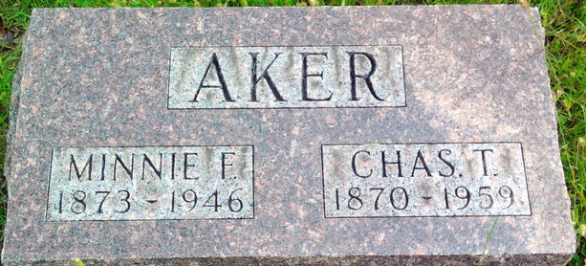
Photo by Thomas Liby

Charles Theodore Aker
in the Indiana, U.S., Death Certificates, 1899-2017
Name: Charles Theodore Aker
Gender: Male
Race: White
Age: 89
Marital status: Widowed
Birth Date: 8 Mar 1870
Birth Place: Indiana
Death Date: 11 Aug 1959
Death Place: Bluffton, Wells, Indiana, USA
Death Registration Date: 1959
Father: William R. Aker
Mother: Eliza Grove
Informant: Can't read; daughter; Bluffton, Indiana
Burial: August 13, 1959; Fairview Cemetery; Bluffton, Indiana

