Connie J. (Sliger) Addington
February 4, 1941 – September 21, 2014

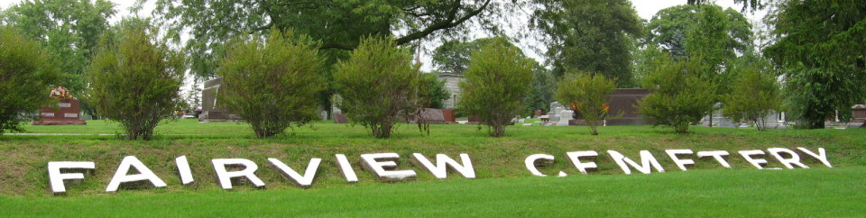
Photo by Tombstoner & Family
Connie J. Addington, 73, of Bluffton, passed away Sept. 21, 2014, at Markle Health and Rehabilitation. Mrs. Addington was born Feb. 4, 1941, to C. Eugene Sliger and Catherine E. Huss Sliger in Bluffton. She married Donald R. Addington June 7, 1959, in Bluffton.
Mrs. Addington graduated from Bluffton High School in 1959 and was a member of Epworth United Methodist Church. She was a homemaker.
She is survived by her husband and a brother, Gary (Lori) Sliger, of Bluffton. Survivors also include a daughter, Gina D. Sizemore; a grandson, Simon (Kristen) Krouse, of Leo; and a great-grandson, Cooper Knouse. Thomas Sliger, a brother, preceded her in death.
Funeral services will be held at 11 a.m. Wednesday, Sept. 24, at Goodwin-Cale & Harnish Memorial Chapel with Tony Garton officiating. Visitation will be from 2 to 8 p.m. Tuesday at Goodwin-Cale & Harnish Memorial Chapel. Burial will be at Fairview Cemetery in Bluffton.
Memorials to the Wells County Friends of the Shelter.

Goodwin Funeral Homes, Wells County, Indiana
September 22, 2014

