William A. H. W. Adams
May 9, 1909 – November 25, 1909

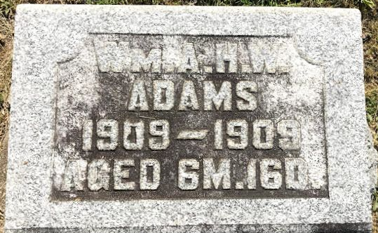
Photo by SMMR
Indiana, U.S., Death Certificates, 1899-2017
Name William Andrew Harvey Wisley Adams
Gender Male
Race White
Marital Status Single
Age 6m 16d
Birth Date 9 May 1909
Birth Place Bluffton, Indiana
Death Date 25 Nov 1909
Death Place Bluffton, Wells, Indiana, USA
Father Amos R Adams, informant
Mother Clara A Fisher
Burial 11-27-1909 Fairview Cem
**
Indiana, U.S., Birth Certificates, 1907-1944

Name Wm Andrew H. W. Adams
Gender Male
Birth Date 9 May 1909
Birth Place Bluffton, Wells, Indiana, USA
Father A. R. Adams
Mother Clara A Fisher
Certificate Number 53559
Roll number 45385_358776
Volume Range 247 - 250

