Violet L. (Judge) Adams
June 15, 1935 – November 25, 2019

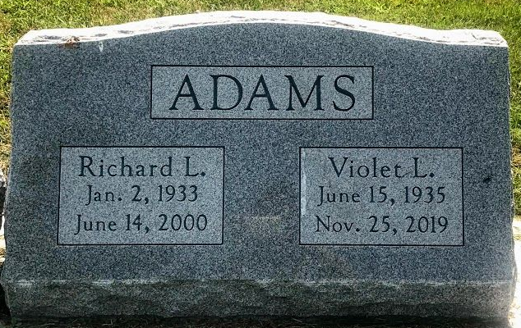
Photo by SMMR

Indiana, U.S., Birth Certificates, 1907-1944
Name Violet Laraine Judge
Gender Female
Birth Date 15 Jun 1935
Birth Place Aboite, Allen, Indiana, USA
Father Noble Judge
Mother Hazel Fay Corwin
Certificate Number 21070
Roll number 40474_357202
Volume Range 39 – 43
**
Violet Laraine Judge from tree General Relativity

Birth 15 Jun 1935 Allen, Indiana, USA
Residence 1993 Lakeland, Polk, Florida, USA
Death 25 Nov 2019
Father Noble Harrison Judge (1889-1978)
Mother Hazel Faye Corwin (1893-1947)
Spouse Richard L Adams (1933-2000)
72775 People 6 Records 6 Sources

