Robert Loren Adams
August 18, 1939 – June 24, 1981

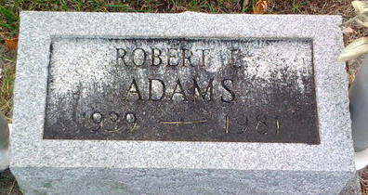
Photo by Thomas Liby

Robert Adams, 41, Dies; Services Here Saturday

Son of Mrs. Duane Hilliard, 909 Clark Ave., Robert Loren Adams, 41, of Ouachita, Ark., died unexpectedly at 9:16 a.m. today of a possible heart attack at Ouachita Memorial Hospital.
Formerly with the Hulcher Co. in Bluffton, and a member of the Eagles Lodge, he was born Aug. 18, 1939, in Muskegon, Mich., to the late Robert Adams and Dorothy B. Foreman Adams Hilliard.
In addition to the mother, he is survived by a son, Duane Adams of Bluffton; three daughters, Twins, Sharon Adams and Karent Adams of Bluffton and Melissa Sue Adams of Nashville, Mich.; two brothers, Gene Adams of Muskegon, Mich., and Donald Adams of Nashville, Mich.
Calling after 10 a.m. Friday will be at the Thoma-Rich Funeral Home. Services there at 10 a.m. Saturday will be in charge of Rev. Eston Poling and burial will be in Fairview Cemetery.

Bluffton News Banner, Wells County, Indiana
June 24, 1981, p. 3, c. 3

