Richard Lee Adams
January 2, 1933 – June 14, 2000

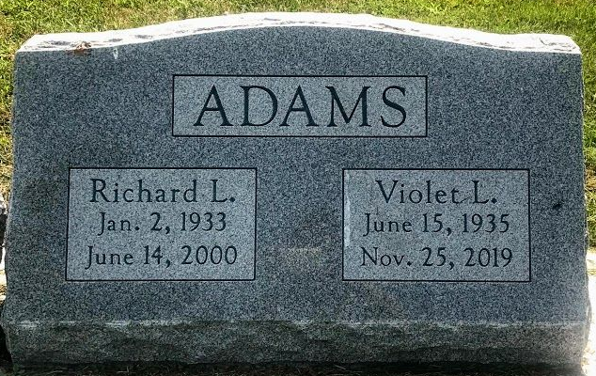
Photo by SMMR

Richard Lee Adams, 67
Brother of five Bluffton residents, Richard Lee Adams, 67 of Lakeland, Florida, died Wednesday at Lakeland Regional Medical Center at Lakeland.
A resident of the Lakeland area since 1979, he had moved there from Glennmore, Ohio. An engineer, he was employed by IMC & Conserve, Mulberry.
He was born January 2, 1933 in Bluffton and was a member of the Woodman of the World Society.
Surviving are his wife, Violet of Lakland; six sons, Richard C. of Blowing Green, Ohio; Mark D. of Grandbury, Texas, and David L., Justin M., Chad E. and Ryan N., all of Lakeland; three brothers, Howard C. of Fort Myers, Florida; Billy K. of Bluffton, and Robert L. of Muncie; four sisters, Betty Johns, Ruth Hollingsworth, Mary Satterfield and Elanda Poff, all of Bluffton; and eight grandchildren.
Funeral services will be private and at David Russell Funeral Home in Lakeland.

Bluffton News Banner, Wells County, Indiana
June 16, 2000

