Patricia J. (Masterson) Adams
October 9, 1937 -

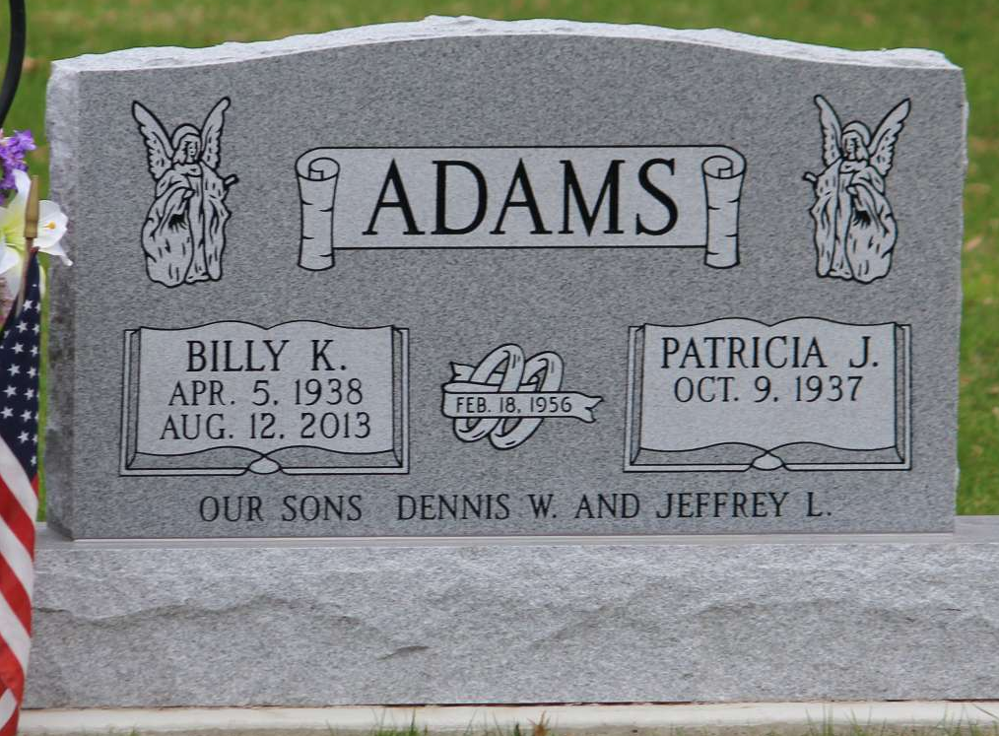
Photo by Tombstoner & Family

